Los Angeles Pierce College Pre-Veterinary Handbook
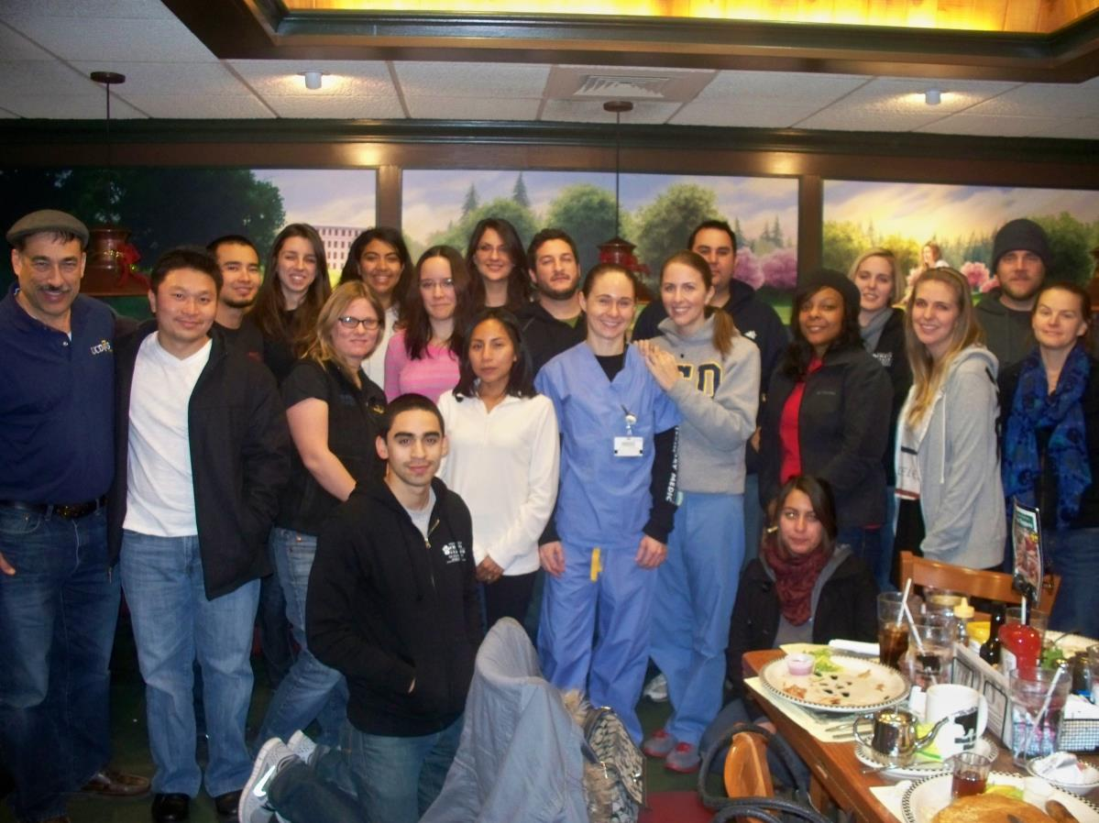

  - THE PIERCE COLLEGE PRE-VETERINARY HANDBOOK
  - Dr. Lu Dao, Director
  - Pre-veterinary Science Program
  - Professor Animal Sciences
  - Los Angeles Pierce College
  - daolt@piercecollege.edu
  - 818 710-4160
  - http://207.62.63.167/departments/agriculture/preveterinary.asp

(updated May 2022)

PREFACE
The purpose of this handbook is to help prepare both the high school student and beginning college student in meeting the entrance requirements for veterinary college. Veterinary colleges receive over a thousand applications every year; however, only 15% of the applicants gain admission. Although this percentage is very low, the Los Angeles Pierce Pre-veterinary Medicine Program has successfully helped students gain admission. Our program has 89% acceptance rate into veterinary colleges for those who complete the degree. We currently have over 300 of our former students either practicing veterinary medicine or are enrolled in veterinary school as this handbook is being published. Our program provides the guidance, the experience, the courses, the letters, and the extracurricular activities and roles necessary to gain admission.
The information contained within this handbook is a summary of the requirements and suggestions on "how to make it." You (the student) need to be diligent in meeting with me at least once a semester to make sure that your goals are being met by your course work, work experience and level of achievement. You should make it a point to participate in the Veterinary Sciences club each and every semester and eventually become a leader. Our program will provide the groundwork to establish a working relationship with a veterinarian in practice through our course ANML SC 181 Field Work club. Your participation in the Veterinary Sciences Club will demonstrate your dedication to helping others in your profession, seeking a life away from your books but still connecting to your profession, will introduce you to others struggling to be accepted in your future vocation, will introduce you to former students who have made it, will allow you to have a fun time during your stay at Pierce College, will provide you leadership opportunities, will provide you opportunities to meet veterinarians from all different fields, and will provide an opportunity to tour a veterinary college.
In 2013, the Regents of the University of California changed the requirements for admission to all graduate schools requiring completion of a Bachelor’s degree prior to matriculation. However, none of the remaining 33 AVMA accredited colleges of veterinary medicine have this requirement. Therefore, Pierce College students are still eligible to apply to any of these colleges. Pierce College students have been accepted into veterinary colleges at Ohio State University, University of Washington, Virginia Maryland University, Kansas State University, Western College in Ontario, Ross University, Colorado State University, and many others. Most of these students have returned to California to practice as a Doctor of Veterinary Medicine. Pierce College students are still eligible to apply to U.C. Davis; however, they will have to transfer to a 4 year university after completing the Pre-veterinary Medicine degree and complete a bachelor’s degree.
Veterinary Medicine is science based. Your choice to become a veterinarian means that you will have to take a heavily science oriented curriculum which will include biology, chemistry, physics, animal science, and math. Working with animals is a large part of veterinary medicine but science is also integral. However, passing many of these courses will not help you gain admission to a veterinary college. The founder of the Pre-veterinary Medicine Program once said, “You can’t just pass the course. You have to master the course.” Self discipline in study habits will be the key to your success. If you are willing to take on this challenge, then you will find one of the most amazing professions in the world. Your job will encompass patients that you have a love and passion for……animals.
Drs. Lu Dao and Leland Shapiro

THE PIERCE COLLEGE PRE-VETERINARY HANDBOOK

ACADEMIC REQUIREMENTS
Pierce students who complete at least 75 semester units, as outlined below, maintain a B+ GPA, obtain their A.S. degree in pre-veterinary medicine, and earn a high score on the GRE exam, obtain hands-on experience with a variety of animals (food producing, companion, research) have an excellent opportunity in competing for admission into the school of veterinary medicine. Three separate GPA's are evaluated; your overall GPA, last 45 semester units and your overall required science GPA. In all cases, you want to aim for the 3.7 level and above to be seriously considered. Work less hours, obtain a tutor, and skip the partying until you are sure you can achieve this goal. Whatever you do, DO NOT blame your failure on a bad teacher, bad upbringing, or bad hair day. Take responsibility for your weaknesses and then work on them. Please come and see me if you should need guidance in this direction, always maintain that positive, "I'm going to succeed" and "I'm going to work harder at it" attitude.
Please note that not all the universities require all the courses recommended in this handbook. However, you will want to qualify for several universities to make yourself more marketable when applying to graduate school. By completing the courses listed and maintaining excellent and not just good grades, you increase your chances in being considered a worthy candidate for graduate school.

Pierce College Requirements for Pre-Veterinary Majors (AS Degree)
Animal Science Course Requirements
ANML SC 120 – Applied Animal Ethics - 3
ANML SC 181A – Veterinary Field Work - 1
ANML SC 401 Orientation to Veterinary Sciences – 1
ANML SC 501 Principles of Animal Sciences – 3
ANML SC 505 Animal Nutrition – 3
ANML SC 506 Urban Farm Animal Health Tech. – 2 or
ANML SC 507 – Small Ruminant Mgt. -2
ANML SC 511 Animal Anatomy and Physiology – 3
ANML SC 512 Anatomy laboratory – 1
ANML SC 596 Animal Enterprise Projects – 1
Required Science Courses
Biology 6 – 5
Biology 7 – 5
Physiology 1 – 4
Physics 6- 4
Physics 7 – 4
General Chemistry 101 – 5
General Chemistry 102 – 5
Organic Chemistry 211 – 5
Biochemistry 221 – 5
Math 227 – Statistics – 4
Microbiology 1 or 20 – 5 units for 1 or 4 units
Not required for Pierce’s degree, however, some graduate schools require Chemistry 212 – Organic Chemistry 2 – 5 units
*Although Chemistry 212 is not listed, some veterinary colleges require this course.
General Education Requirements
English 101 – 3
English 102 OR 103 – 3
Health - 1
History or Poli Sci – 3
Communications (such as Speech) - 3
Please check the current catalogue for any additional general education requirements
Most Veterinary Schools also require a genetics course (upper division) prior to applying.
In addition to the above courses, UC Davis, and most other colleges require one additional course that must be taken at a four-year institution (CSUN or UCLA are the recommended universities for the remaining course work):
Genetics-Principles of Genetics (4 units)
Upper division courses can be taken online through the University of California (UC) system or in person at California State University Northridge (CSUN). CSUN credit courses are offered through the Open University program. All you need is a CSUN student account which can be created for free and a permission number. During these tough economic times students may need to take an online course in Genetics (if there is no room in the concurrent enrollment program at the CSU). Students can request a CSUN student account and a permission number by using this link:
https://tsengcollege.csun.edu/programs/spring/next-steps
Students can learn more about Open U by clicking here:
https://tsengcollege.csun.edu/programs/spring
or by emailing collexl@csun.edu.
UC Davis also accepts the following online genetics course from UC Berkeley (there are additional online courses at ISU and KSU that may also be accepted):

Genetics
X143 (3 semester units in Molecular and Cell Biology) 45 hours CE credit: BRN provider #00226
This course integrates the most important concepts in classical and molecular genetics into an overall picture of what a gene is, how it functions, how it may be altered, and how it is inherited.
You learn about the molecular basis of gene function and mutation, Mendelian genetics, transmission systems, regulation of cellular processes, developmental genetics, cytoplasmic inheritance, population genetics, and multifactorial inheritance. Also covered are recent advances in biotechnology that have genetic implications, including the Human Genome Project, and advances in genetic engineering technology.
Prerequisite: A year of college-level general biology for majors.
Click below for sections, start dates, locations, instructors, and to enroll.
http://www.unex.berkeley.edu/cat/course358.html#
Ross University, St. George University, St. Mathews and Western University will accept Pierce College's biology 110 course as meeting your genetics requirement.
Not every student will require the same course work or require the same sequence in courses. Depending on your previous experience, your GPA, your success in a particular class, I may direct you to go in a different direction than another student. Please confer with me each semester as to the particular sequence of classes you are enrolling in. The following Experiential Courses and Recommend Courses will vary depending on the aforementioned and the school you are applying to.
Pierce Pre-Veterinary Experiential Training (to provide hands-on experience under the direction of a veterinarian)
ANML SC 441 – Large Animal Nursing 2
ANML SC 507- Small Ruminant Management 2
ANML SC 515/516 – Artificial Insemination lecture/lab 3 ANML SC 520/521 - Beef Production
ANML SC 530/531 – Poultry Production 4
ANML SC 535/537 - Sheep Production 4
ANML SC 603 - Equine Mgt. Techniques 2
ANML SC 650 - Equine Health and First Aid 2 ANML SC 596 – Agricultural Enterprises
For those students who are ONLY interested in Western University of Veterinary Medicine please follow these listed articulations from Western U.

Table for Articulation with Western College of Veterinary Medicine
Los Angeles Pierce College | Western College of Veterinary Medicine
Biochemistry | CHEM 221
Biological and Life Sciences | - Lower Division: BIOL 3, 6, 7, 10, 11, 12, 18; PHYSIOL 8, 9;
Biological and Life Sciences | Upper Division: ANSC 430/431 (must take lab to use), 501, 505, 510, 511/512, 515/516 (must take lab to use); PHYSIOL 1
English | ENG 101, 102, 103, 127; PHILOS 5
Genetics | BIOL 110
Humanities/Social Science | Any Non-Science Courses are Acceptable (Examples include: Anthropology, Psychology, Sociology, Art, Foreign Language, History, Philosophy, Religion, Drama, Music, etc.)
Microbiology | MICRO 1, 20
Organic Chemistry | CHEM 211, 212 (labs included)
Physics | PHYSICS 6 and 7; 66 and 67 (Preferred)
Physiology | ANML SC511; PHYSIOL 1
Statistics | MATH 227; STATISTICS 1,7
Listed prerequisites are subject to change without prior notice
The Pierce College Pre-Veterinary Medicine program, however, recommends that you prepare for entry into more than one school and meet more than the minimum qualifications to be more competitive when applying.
For students interested in Ross University School of Veterinary Medicine
An articulation agreement is established with Ross University to reserve 5 seats every semester for Pierce College Students completing the Pre-veterinary Medicine Associates Degree. The agreement shortens the period of the doctor of veterinary medicine program to 3.25 years from 4 years. Please contact Dr. Dao for further details.

GRADES AND GRADES
GRADES and GRADES - You will hear from some veterinarians that grades are not all that important. Others will tell you that you need straight A's. The real answer is somewhere in between. You do need good grades, as previously outlined. If you receive one "C" - it is not the end of the world. You can still make it. If your average GPA is in the "C" range, you need to buckle down and change that - immediately or perhaps look at an alternative career in animal medicine. I will be happy to guide you in that direction, as well. Pierce has an excellent Registered Veterinary Technician program which does not require as stringent GPA and course work.
Before taking the GRE exam, students should complete as many of the science courses as possible. There are three major sections to this exam: verbal, quantitative, and essay. It is approximately 3 1/2 hours long.
There are preparatory courses and books. You may also want to contact the Stanley Kaplan GRE Review Course at 204 "F" Street, Davis, CA (530) 753-4800 for preparation manuals. The ETS Practicing to Take the GRE and Harcourt Brace Javonovich Manuals are also excellent review sources. Examples of old GRE test questions are available through the Educational Testing Service (ETS) for a minimal charge. Write or call ETS for more information. (P.O. Box 23470, Oakland, 946230470;[415]653-5400). Exams are offered twice a year. For an extra fee you can take the GRE by Special Administration Service test centers on dates other than those provided on National Administration test dates. An applicant with a marginal GPA can really strengthen his/her application with an excellent GRE score. If you do not do well the first time you take the GRE take it again. The admissions committee only looks at your most recent scores. Allow enough time to take it a second time, if need be.

Veterinary and Animal Related Experience

All pre-veterinary medicine students should acquire a diverse (food animal, small animal, poultry, exotics, equine, research) experience in the veterinary medical field prior to applying to veterinary school. The purpose of this is four-fold:
1) It demonstrates a sincere desire by the student to a career in veterinary medicine.
2) It allows the student to develop a realistic understanding of the veterinary profession.
3) This understanding will greatly assist the student in the narrative portion of the application.
4) It helps the student define his/her goals and objectives within the profession.
The type and degree of experience required varies from college to college and varies due to the background of the applicant. Applicants born and raised on commercial animal farms probably received a tremendous hands-on experience at home with large animals and could therefore concentrate more on companion animal and research animal experience. In any case, experience in a variety of animal type practices (including research) is generally recommended. Even though your work experience is important, you will NOT be considered a worthy candidate without proper grades. Do NOT let your grades suffer because you are working too many hours. Save your long work experience hours for summer and other school breaks. You can always make up missed hours of experience. You cannot make up four years of poor performance (grades). STUDY!

What are Your Chances of Being Accepted?
From 1997 - 2014, one hundred and fifty-seven Pierce College students applied to veterinary school; one hundred and forty-one were accepted. In 2015, 20 Pierce students applied. Of these 18 were accepted and two were placed on waiting or alternate lists. And in 2016, nine out of ten Pierce applicants were admitted into one or more graduate schools. These were exceptionally good years for our program. We hope to continue this success and hope you will understand when we demand excellence in performance and many hours of work. We hope to prepare you for the marathon (veterinary school). You cannot expect to be prepared for a marathon by running hundred-yard dashes (taking one class at a time). On the same thought, if you over extend yourself by taking too many classes (try and limit your class load to 16-18 units/term) you will be worn out by the time you apply or unable to maintain that high GPA that will make you shine on your application.
At some veterinary colleges, evaluation of applicants are based on: Overall GPA = 11%, science GPA = 5%, last 45 units (taken in two years or less time) GPA = 12% or a total of 28%. GRE scores (general aptitude test) = another 28%. 20% = the interview. 6% = references. 18% = an essay written about why the student wants to be a veterinarian, veterinary experience, understanding of the veterinary profession, extracurricular activities (such as the pre-veterinary club). Note: These percentages may vary slightly year to year.
Pierce students who have been accepted into veterinary school have generally exceeded the following scores:
GPA last two years should average 3.7 or greater.
GPA overall should average 3.5 or greater
GPA for science overall should average 3.5 or greater.
GRE scores should average>80% for verbal, quantitative and analytical
Please complete the following information sheets throughout your stay at Pierce College. They are meant to guide you along the way and to demonstrate what will be required of you when you ask for a letter of recommendation to a school of veterinary medicine. Good luck and never give up! If your heart, your motivation and your preparations are sincere, YOU WILL MAKE IT!
Remember the old farmer's parable:
This parable is told of a farmer who owned an old mule. The mule fell into the farmer's well. The farmer heard the mule praying -or-whatever mules do when they fall into wells. After carefully assessing the situation, the farmer sympathized with the mule, but decided that neither the mule nor the well was worth the trouble of saving.
Instead, he called his neighbors together and told them what had happened . . . and enlisted them to help haul dirt to bury the old mule in the well and put him out of his misery. Initially, the old mule was hysterical! But as the farmer and his neighbors continued shoveling, and the dirt hit his back, a thought struck him. It suddenly dawned on him that every time a shovel load of dirt landed on his back he should shake it off and step up!
This he did, blow after blow. "Shake it off and step up . . . shake it off and step up . . . shake it off and step up!" He repeated to encourage himself. No matter how painful the blows, or how distressing the situation seemed the old mule fought "panic" and just kept right on shaking it off and stepping up!!!
It wasn't long before the old mule, battered and exhausted, stepped triumphantly over the wall of that well! What seemed like it would bury him, actually helped him all because of the manner in which he handled his adversity.
That's life! If we face our problems and respond to them positively, and refuse to give in to panic, bitterness, or self-pity . . . The adversities that come along to bury us usually have within them the very real potential to benefit us! Never be afraid to try something new. Remember, amateurs built the ark. Professionals built the Titanic! Never be afraid to learn, to work hard, and to try something you are not good at!

Tribute to and History of Dr. Leland S. Shapiro at L.A. Pierce College, Founder of the Pierce College Pre-veterinary Medicine Program
Dr. Shapiro is the grandson of a farm laborer immigrant who milked cows on 92nd street in Watts. His mother grew up in Watts and his father in East Los Angeles. He lived overseas for two years including a year in Eastern Nigeria during the Biafra Civil War.
In 11th grade Dr. Shapiro moved to the San Fernando Valley. He had run cross country at Pierce College in 1968 when the farm had more acres and thousands of additional animals.
In 1971, Dr. Shapiro started working for Pierce College. His first job was as a farm tour guide working with Community Services’ “Day on the Farm” program. There he toured 20,000 inner city children on the Pierce’s farm, and provided them free lunches (sponsored by McDonalds and Carnation Co). At that time, Pierce had 114 head of dairy cattle, 350 beef cattle, 250 sheep, 250 pigs, 6,000 chickens, a 15-acre orchard and 200 acres of pasture and field crops.
Dr. Shapiro soon acquired additional hours working for the college’s farm manager. He worked in the poultry unit, fixed fences, moved irrigation pipes, prepared feed in the college’s working feedmill and eventually landed a job at the college dairy. One of his “charges” was to care for Pierce’s mascot, Clarence the Brahma Bull (see photo):
Pierce College provided this “inner city kid” an opportunity to learn, with hands-on experience, the workings of a real farm. Dr. Shapiro was in the first animal health technology program at Pierce College under the leadership of Dr. Frank Baugh. Dr. Shapiro eventually transferred to Cal Poly State University in San Luis Obispo. He earned a Bachelor of Science degrees in Dairy Science and biology (as a minor) and an MS degree in Agricultural education with mammary physiology as his research emphasis. He became student herdsman at Cal Poly’s foundation dairy unit. He continued with his education earning a PhD in Reproductive Physiology with a declared minor in Agriculture Education from Oregon State University and completed two post- doctoral studies in bioethics (one from the Kennedy Institute of Ethics at Georgetown University and the second from Iowa State).
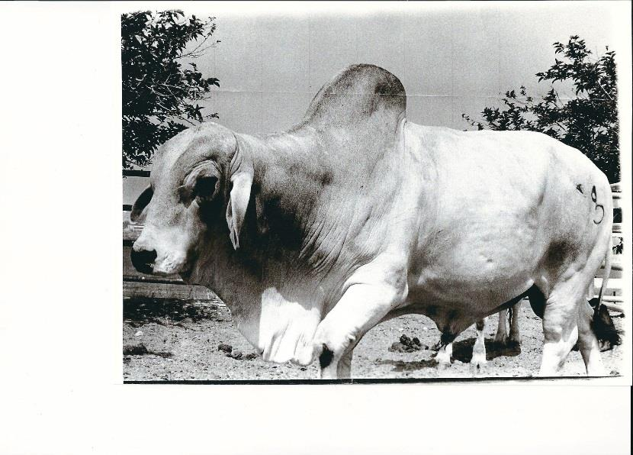
In 1976, the dairy herdsman at Pierce College broke his leg and the dairy instructor gave a two-week notice. The dean at Pierce College, Frank Baugh asked Dr. Shapiro to take both positions for one semester. He did, fell in love with teaching and working on the farm and stayed for almost 40 additional years. At the beginning, he developed a processing plant through a grant and started producing and marketing Pierce milk in the campus farm store, cafeteria and, in addition, sold Pierce milk in cartons bearing the name “Peter J. Pitchess Honor Rancho.”
Dr. Shapiro was also one of three professors who created the Pierce College Farm Walk (1976). This annual event brought in needed funds for the farm and helped educate more than10,000 visitors to the farm each and every year. In the earlier days, Dr. Shapiro taught “cow milking” on Huell Howser’s Saturday morning Agriculture shows.
When the Pierce dairy closed in June of 1990 and the Pierce Dairy Science program ended, Dr. Shapiro was challenged by the dean to create a unique Pre-veterinary program to meet the needs of many of Pierce’s animal science students. Working with Dean Osborn of UC Davis’ School of Veterinary Medicine, Dr. Shapiro created the Pierce Pre-veterinary degree/program with articulation and/or agreements, eventually, sending 278 Pierce students to 23 graduate schools of veterinary medicine. Success rates have averaged greater than 87% of students applying being admitted into at least one graduate school. During Dr. Shapiro’s tenure as Department Chair of Agriculture, he solicited and received more than $350,000 in grants and donations to the department. Grants included a $150,000 Annenberg Foundation Grant for student labor on the farm, two USDA grants (one to increase Hispanic student numbers in the veterinary and animal science field and one to bring a foreign student from Africa to learn on the Pierce College farm.)
Dr. Shapiro has been a long-time member of the American Dairy
Science Association, Dairy Shrine Club, Gamma Sigma Delta Honor
Society of Agriculture, and Association of Veterinary Technician
Educators, Inc. He is on the Board of Directors for the Society for
Veterinary Medical Ethics and the Americans for Medical Progress. Dr.
Shapiro was a dairy farmer for almost two decades, holds a California
State pasteurizer’s license and for 14 years was a certification
instructor for artificial insemination. Dr. Shapiro is a University of
California Davis “Mentor of Veterinary Medicine,” and the recipient of
several local college teaching awards as well as the prestigious
National Institute for Staff and Organizational Development
Community College Leadership Program (NISOD) Excellence in
Teaching Award, in Austin, Texas and professor of the year award at
Los Angeles Pierce College. In 2018, Dr. Shapiro was inducted into
the Dairy Science Hall of Fame at Cal Poly State University in San Luis
Obispo.
Dr. Shapiro has served as a consultant for the college of veterinary
medicine at Ross University and has authored 17 books of which six
are sold internationally. His last book was written to fund student
scholarships at Pierce College. 100% of the proceeds from Fun Corny
Farm and Veterinary Jokes is donated to the Boggess Memorial
Scholarship fund at the Foundation for Pierce College.
On September 8, 2015, Dr. Shapiro retired from Pierce College. He
was very proud in being able to leave his program in the capable
hands of one of his former students, Dr. Lu Dao (see photo):
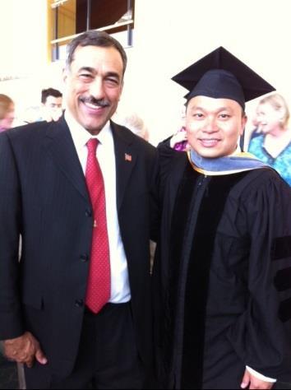

PRE-VETERINARY LETTER OF RECOMMENDATION QUESTIONNAIRE
Date________________
Major ________________________
Full Name: (last name, first) ____________________________________________________
Local Address: ___________________________City_________________ Zip__________
Local Phone: _____________________________ E-Mail: ________________________ Entered college in ___________20 _________ Expect________degree in ____20 ___
College activities (athletics, publications, pre-veterinary club, etc., with average number of hours per week, offices in club held and when):
Freshman year___________________________________________________________
________________________________________________________________________
________________________________________________________________________
Sophomore year ___________________________________________________________
________________________________________________________________________
________________________________________________________________________
Junior year _______________________________________________________________
________________________________________________________________________
________________________________________________________________________
Senior year _______________________________________________________________
________________________________________________________________________
________________________________________________________________________
Outside work during school year (state nature of work, with average number of hours per week): Freshman year
______________________________________________________________________
Sophomore year__________________________________________________________
Junior year _______________________________________________________________________
Senior year _______________________________________________________________________
Animal care related experience (give nature of position, the organization and location, hours per week, and length of time for each one listed):
________________________________________________________________________
________________________________________________________________________
________________________________________________________________________
________________________________________________________________________
________________________________________________________________________
Research experience: ________________________________________________________________________ ________________________________________________________________________
Work, travel or other experiences (during the past two summers): ________________________________________________________________________ ________________________________________________________________________ ________________________________________________________________________
Make sure you have applied for you’re A.S. Degree in Pre-Veterinary Medicine prior to asking for this letter of recommendation.
Undergraduate grade point average: Overall GPA ______
Overall Science GPA ______
Last two years GPA ______
GRE Scores: Verbal ______ Quantitative ______ Analytical ________
I expect to apply for admission in September, 20 ____, to __________________ veterinary school or ___________________ graduate school
(list major if choosing grad. school) _______________________________________
Last year attended Pierce, list classes, when taken and grades given by Dr. Shapiro and/or Dr. Dao___________________________________________________________
___________________________________________________________________
Grades earned in Biochemistry and Physiology 1?
List Offices held while in the pre-veterinary club ________________________________
_______________________________________________________________________
Other comments (you may use additional sheets):
________________________________________________________________________
________________________________________________________________________
________________________________________________________________________
________________________________________________________________________
For the schools you are applying to please provide me with individual stamped envelopes with each schools name and address typed across the front (or simply apply through VMCAS to complete all the letters on line). Check off the “waived” portion of your application. Give me ample time to create a proper letter of recommendation to go along with your application. Return to:
Dr. Lu Dao, Co-Director or Pre-Veterinary Science Program daolt@piercecollege.edu
Dr. Leland S. Shapiro, Co-Director Pre-Veterinary Science Program shapirls@piercecollege.edu

